Output Window:
Person Long Name
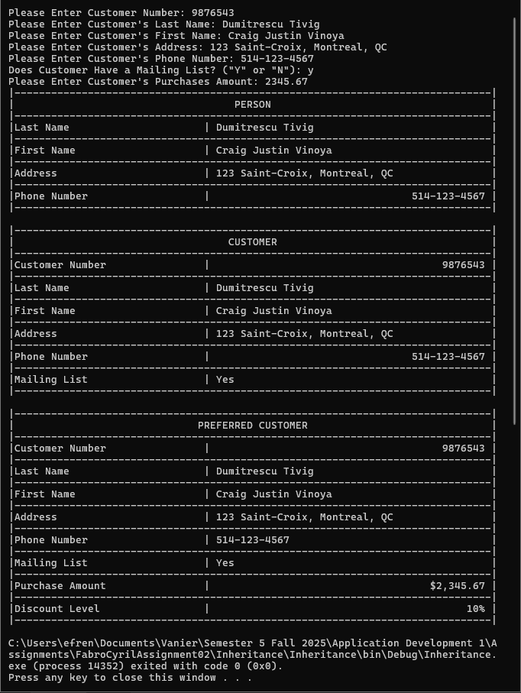

Customer “Yes” Mailing List

Customer “No” Mailing List
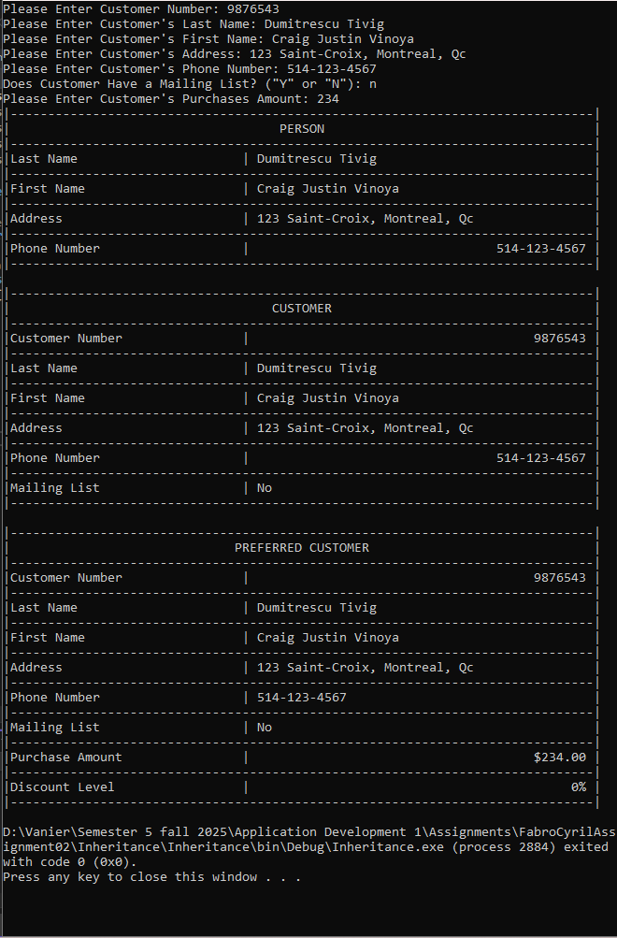
Preferred Customer Discount Level 0%

Preferred Customer Discount Level 5%
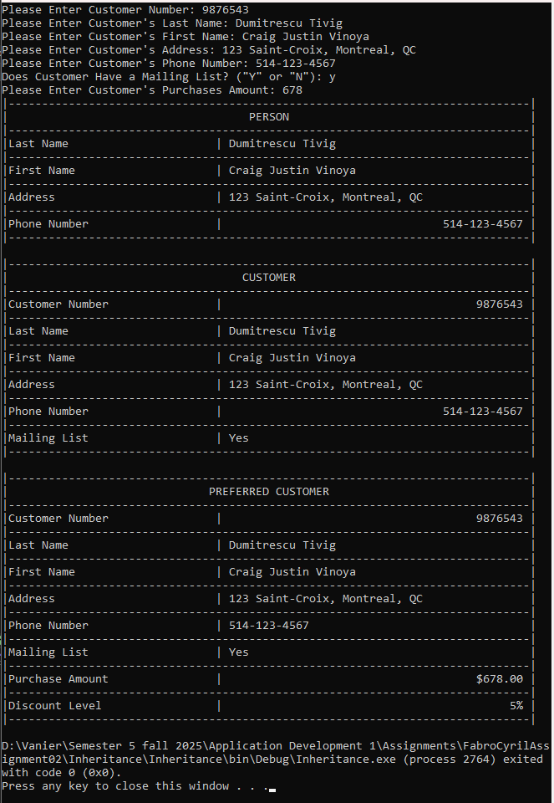

Preferred Customer Discount Level 6%
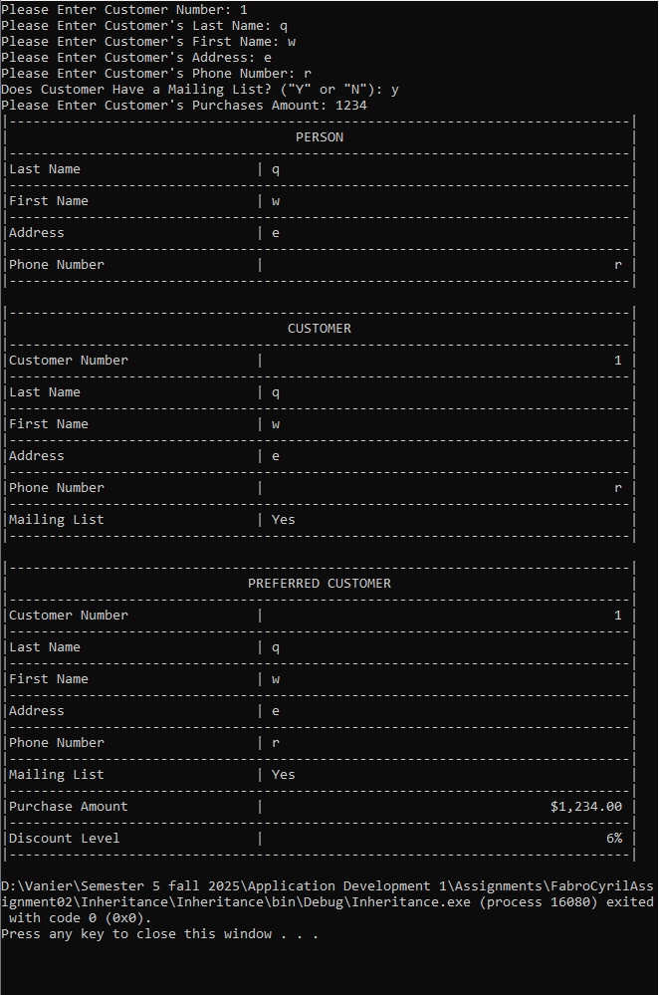

Preferred Customer Discount Level 7%
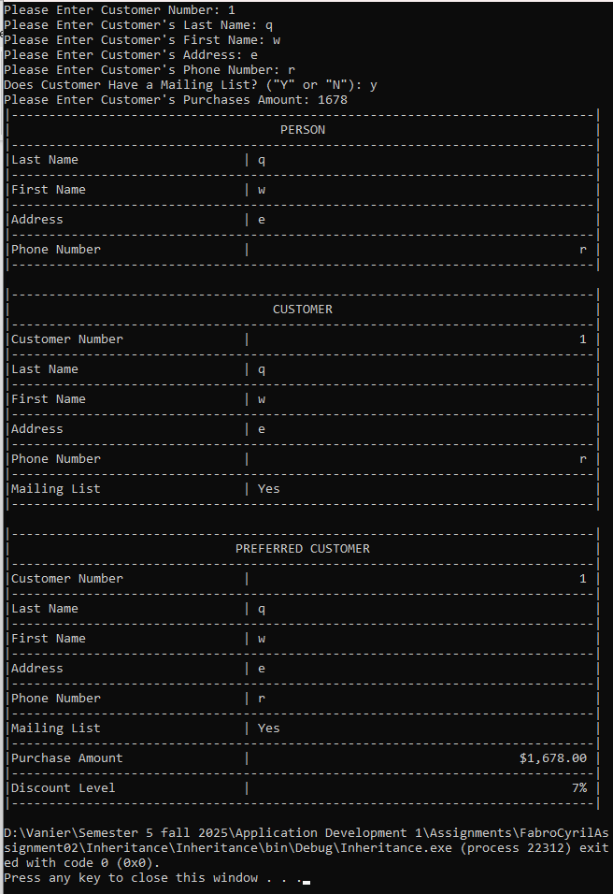

Preferred Customer Discount Level 10%

